**Assignment 2:**

Create 3 private repositories on GitHub.

* In the first private repository, under the master branch, add index.html.
* In the second repository, under the 2025Q1 branch, add index.html.
* In the third repository, under the 2025Q2 branch, add index.html.

Then, create 3 different jobs on Jenkins.

* When the first job is built, the content in the index.html file under the master branch should be reflected similarly for the other jobs.

Ans: job-1

* 1. Git integrate

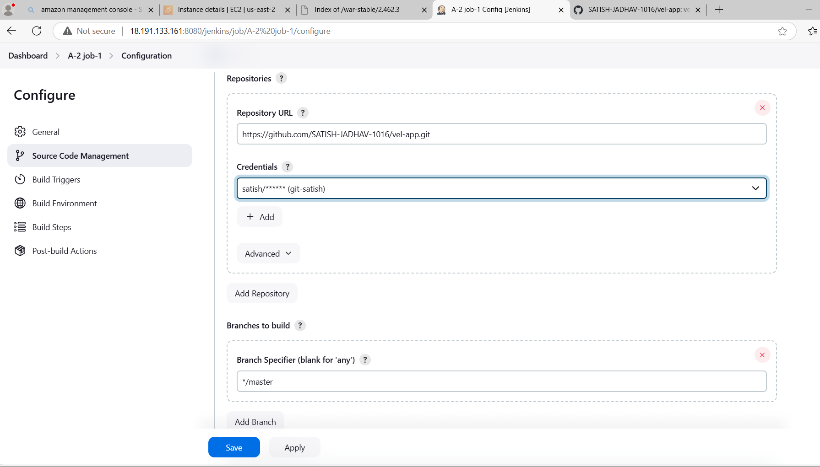

* 1. Execute shell

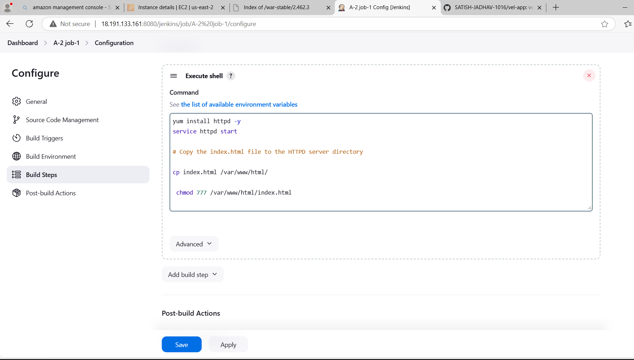

* 1. Console Output

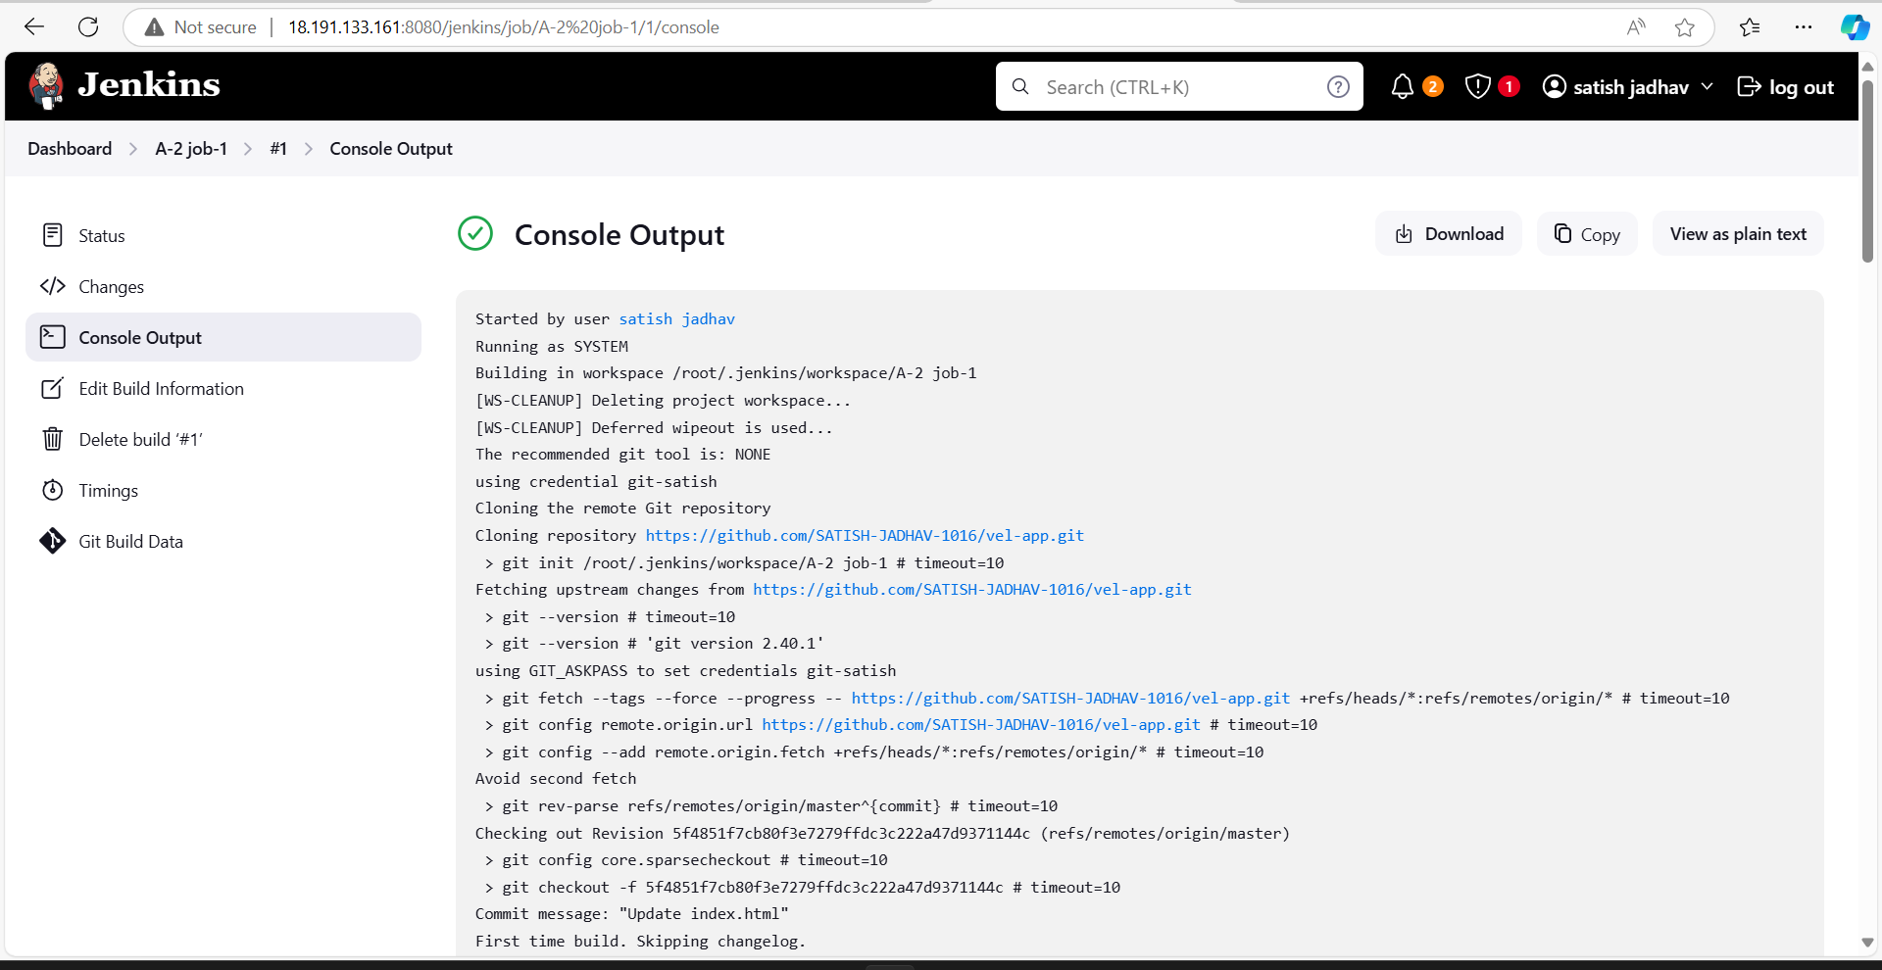

* 1. public ip

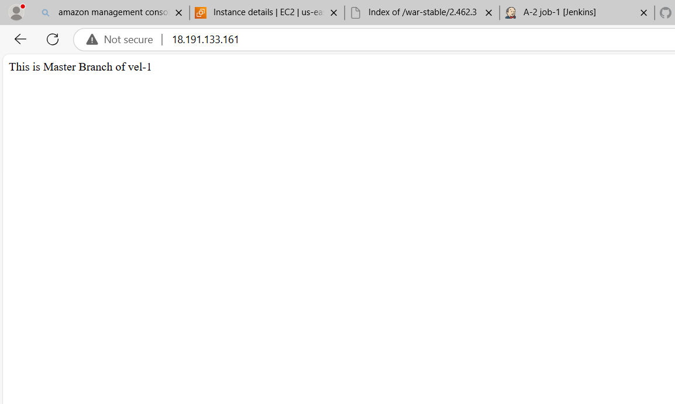

J0b 2 :

* + 1. Git integrate

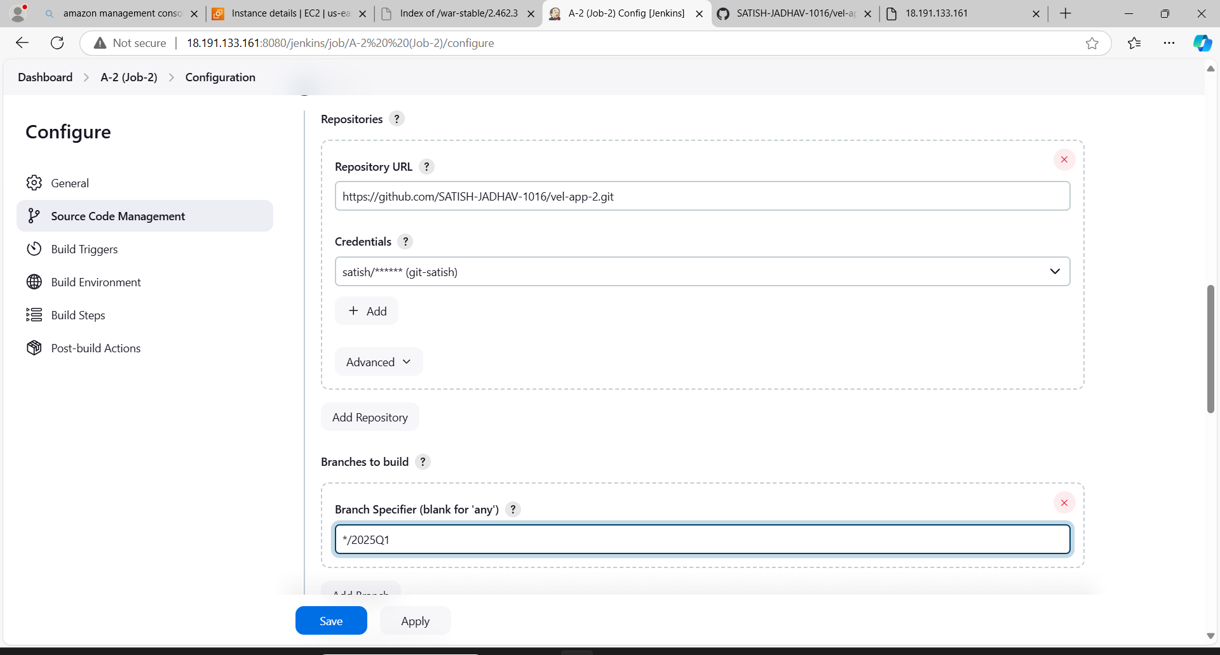

2) Execute shell

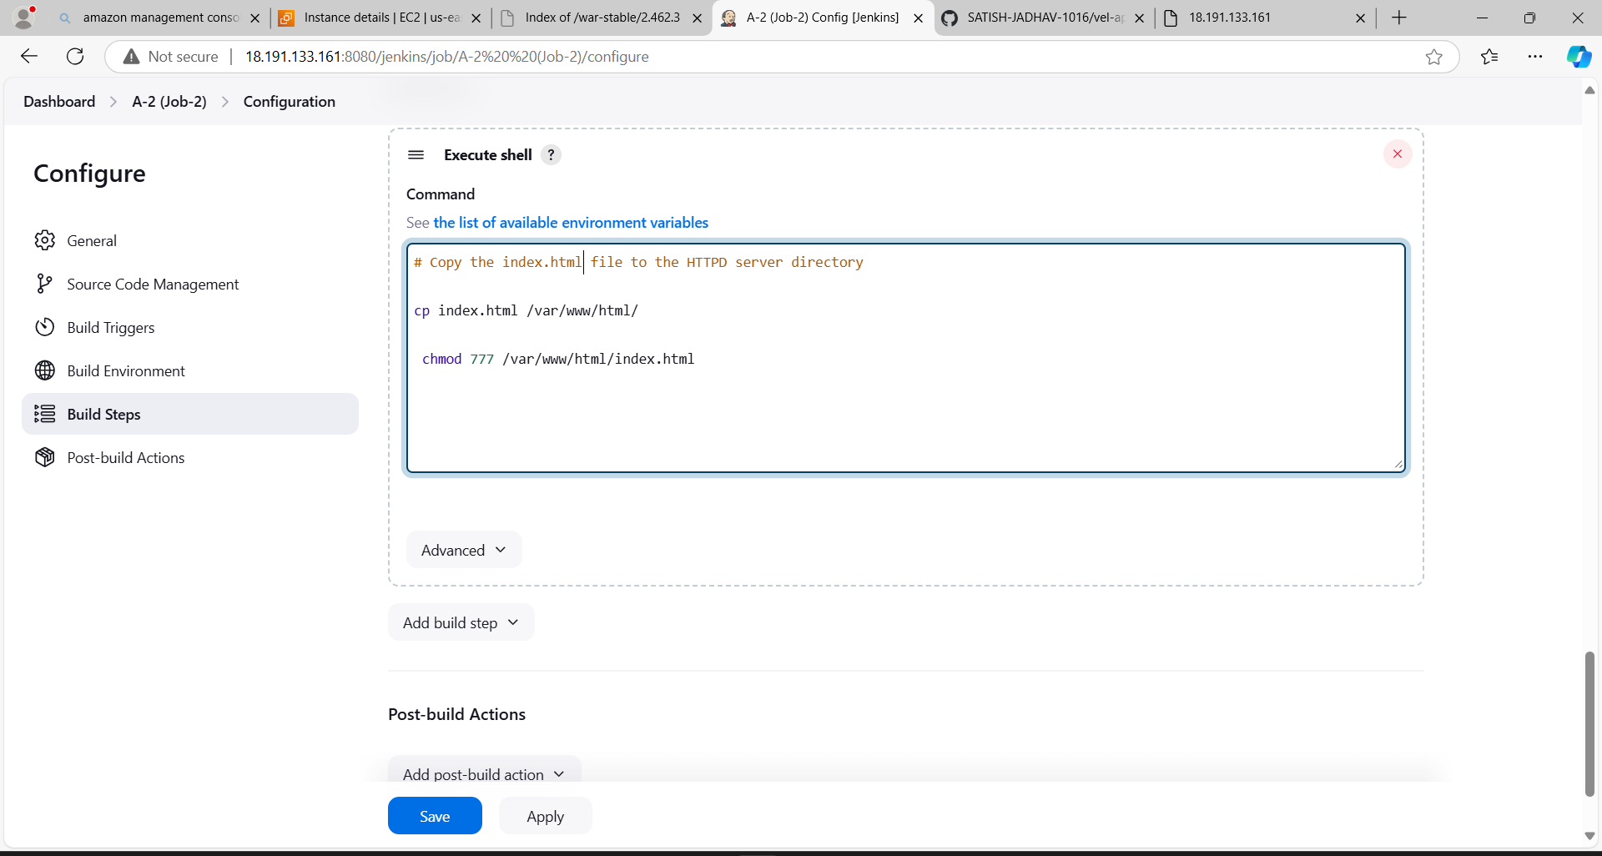

3)Console Output

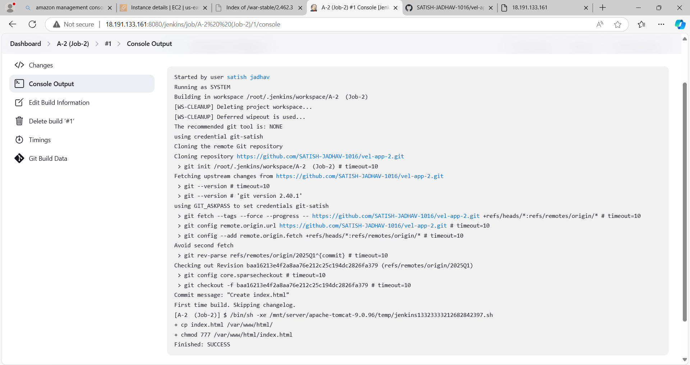

4) public ip

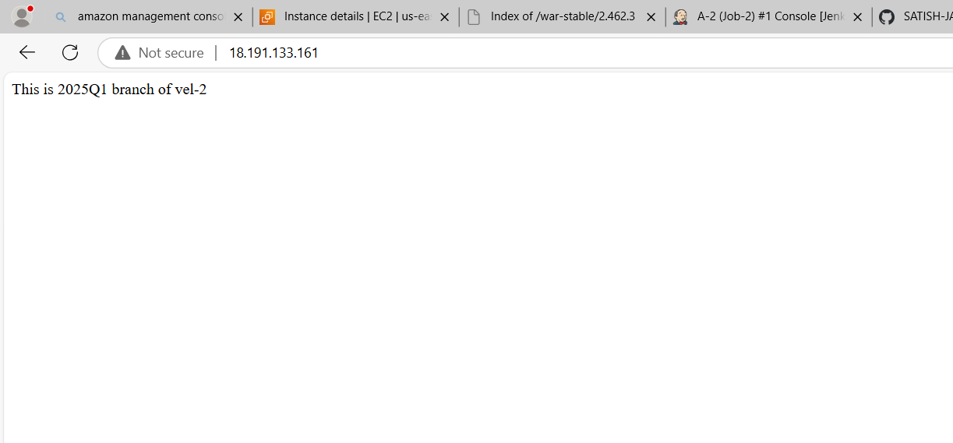

Job 3

1)Git integrate

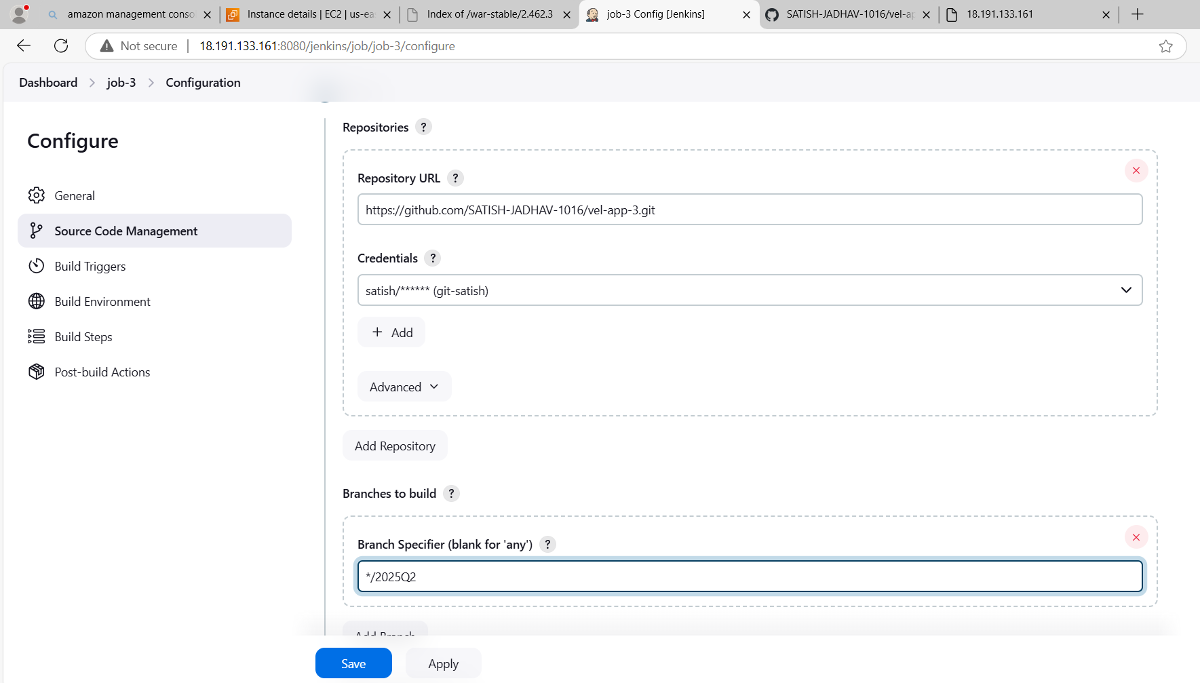

2) Execute shell

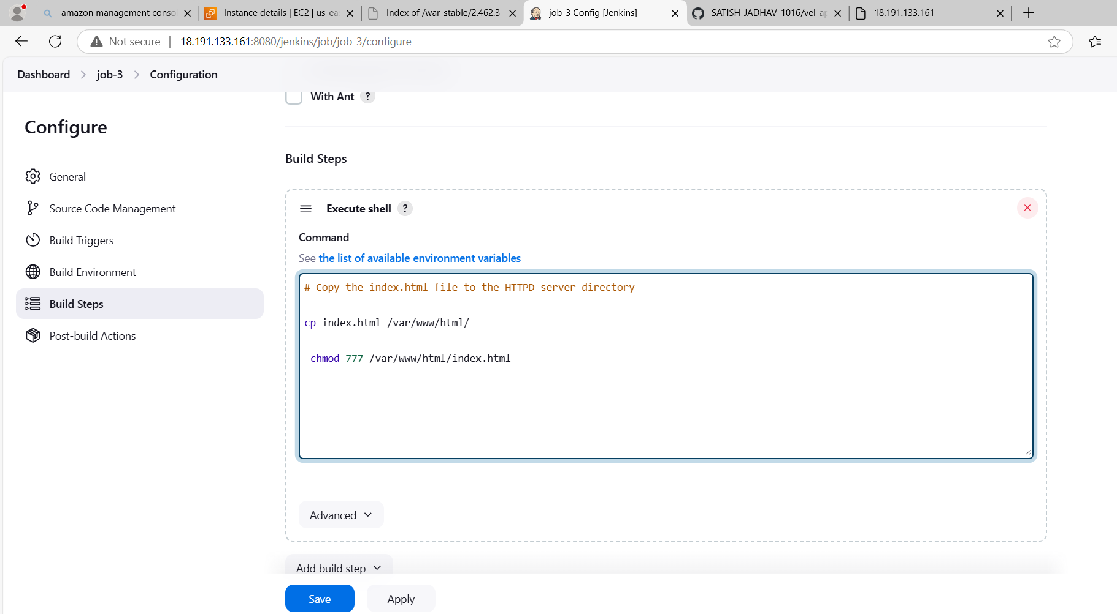

3)Console Output

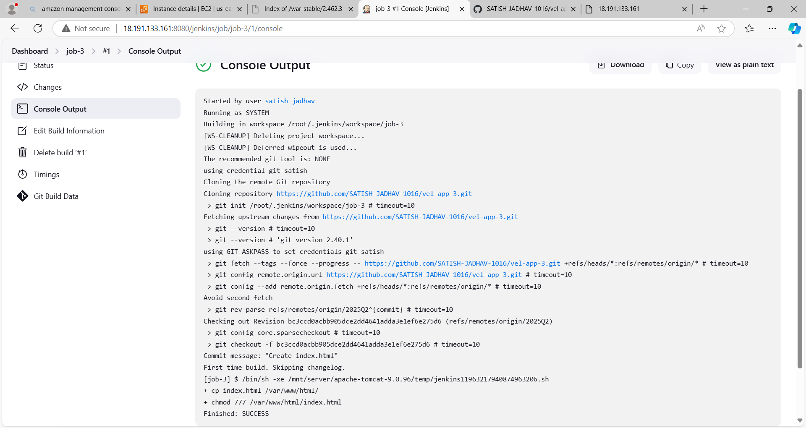

4)public ip

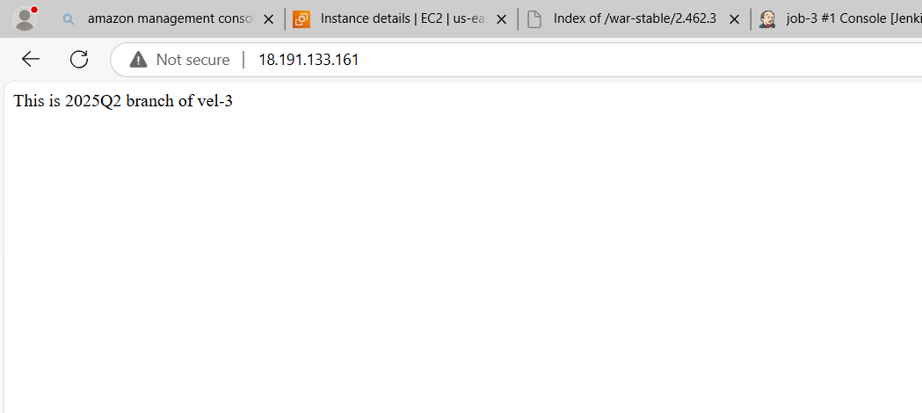

All three job

